Dr. Vikram Sarabhai Rotating Shield Quiz 2015  
  
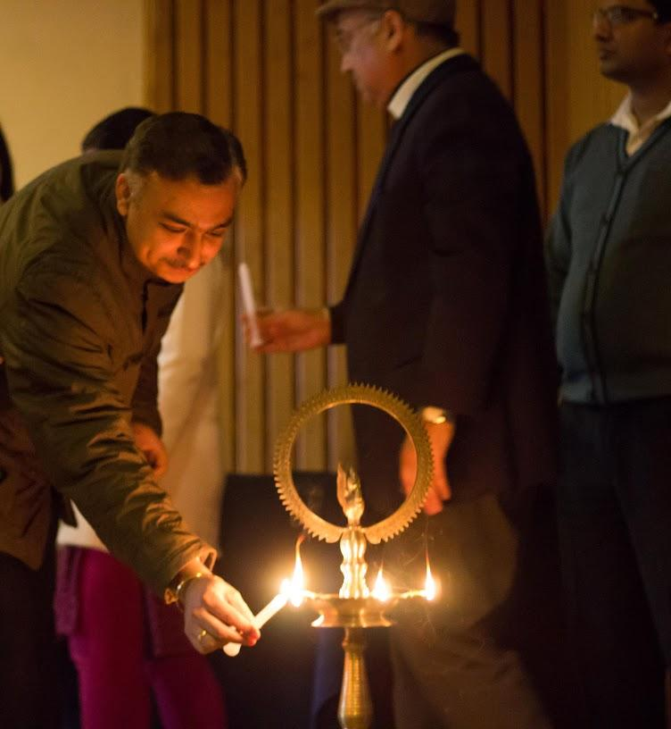  
  
BVPIEEE, the IEEE student branch of Bharati Vidyapeeth’s College Of Engineering conducted the 8th edition of Vikram Sarabhai Rotating Shield Quiz inter-college quiz competition on 4th February, 2015 in the college auditorium.

The quiz is one of the premier events of our student branch. This year too, the event saw a stupendous success. Statistics bear out the enormous response that was received as more than 150 ardent teams participated – most of them comprising of two members each, barring some lone wolves who battled like a one-man army. Prizes up to Rs. 10,000 were up for grabs.

The event kicked off with an inaugural ceremony initiated by our Honorable Principal, Prof. Dharmender Saini and, Branch counselor, Mr. Rahul Bahl. The quizmasters for the quizzing extravaganza were Karthikeya Ramesh, Subhav Duggal and Aryaman Nath. The quiz had three rounds. The teams gave a stiff competition to each other. Out of the 150 participating teams, 30 qualified. From the top 30, the top 6 teams were selected. And after a tough battle of brains, the top 3 position holders were announced. The top three teams that made it to the podium after dodging the questions were:

1. Shashank Singh and Shashwat Nagar from NSIT
2. Mohd. Fahad and Lavanya Singh from DTU
3. Aditya and Shivendra from DTU

The NSIT Collegiates walked away with the top spot. Meanwhile DTU students ruled the roost, grabbing two out of top three positions. In addition to the cash prizes, the winners were also awarded certificates of honour. The winners of the First prize were also awarded a shield. Finally, the event was brought to a conclusion by Mr. Rahul Bahl’s golden words.

Sagacious and astute answers kept the spirit of competition alive. All in all, it was an engrossing and stimulating event that lived up to its billing as one of Delhi's top inter-college quizzes. The success of the event left the avid quizzers to earnestly wait for the next edition.

